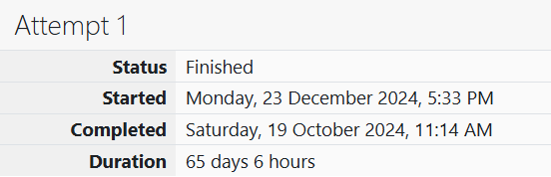

ROLL NO.: 241801281

NAME: SUJITHA NEELAKANDAN VIGNESHWARI

WEEK 01-02 PRACTICE SESSION

1.OBJECTIVE:

Write a program to input a name (as a single character) and marks of three tests as m1, m2, and m3 of a student considering all the three marks have been given in integer format. Now, you need to calculate the average of the given marks and print it along with the name as mentioned in the output format section.

CODE:

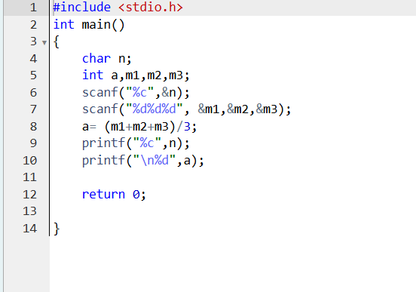

OUTPUT:

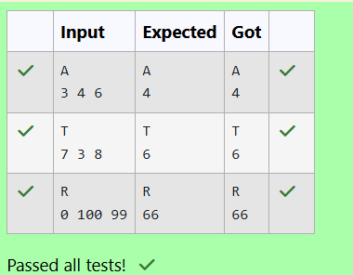

2.OBJECTIVE:

Print each element on a new line in the same order it was received as input. Note that the floating point value should be correct up to 3 decimal places and the double to 9 decimal places.

CODE:

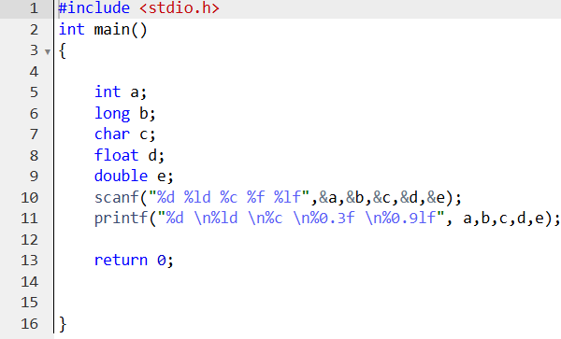

OUTPUT:

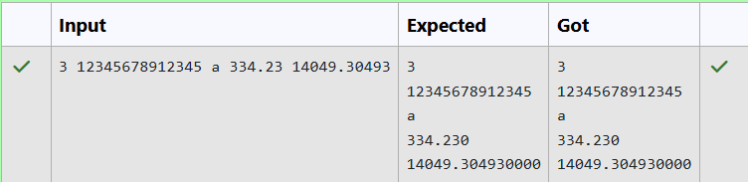

3.OBJECTIVE:

Write a program to print the ASCII value and the two adjacent characters of the given character.

CODE:

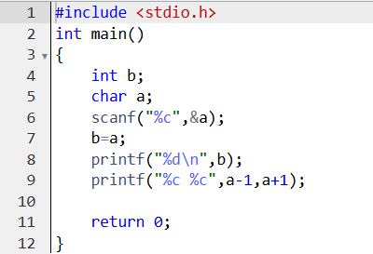

OUTPUT:

